Book Sharing application Proposal

Functionalities

1. Register student to the system.
2. Login as Student to the system
3. Logout from the System.
4. Add books to the system.
5. Update book record in system
6. Delete book from system.
7. Search book all from system.
8. Borrow book form system.
9. Return book form system.

Views:

* Login View
* Register user view.
* Dashboard view.

Dade line: Feb 7

Technology:

Java (JDK 17) , FX SDK -21 , MySQL ,PhpMyAdmin

Source control via GIT

IDE : Eclipse ,Sean Builder

Deliverable Milestone:

* Create local setup for Java +FX+ PhpMyAdiin and commit change to report repo. - Done

<https://github.com/umayanga123/BookShareSystemApplication>

* Create Login Page - Done
* Create Login Functionality with error handling. – Done
* Create User Registration View and functionality. – Done
* Create book Adding functionality.
* Create book search functionality. – Done
* Create book update functionality.
* Create book delete functionality.
* Create Main View – borrow and lending books. – Done

Timeline – To be Added.

Screen shot:

PhpMyAdmin

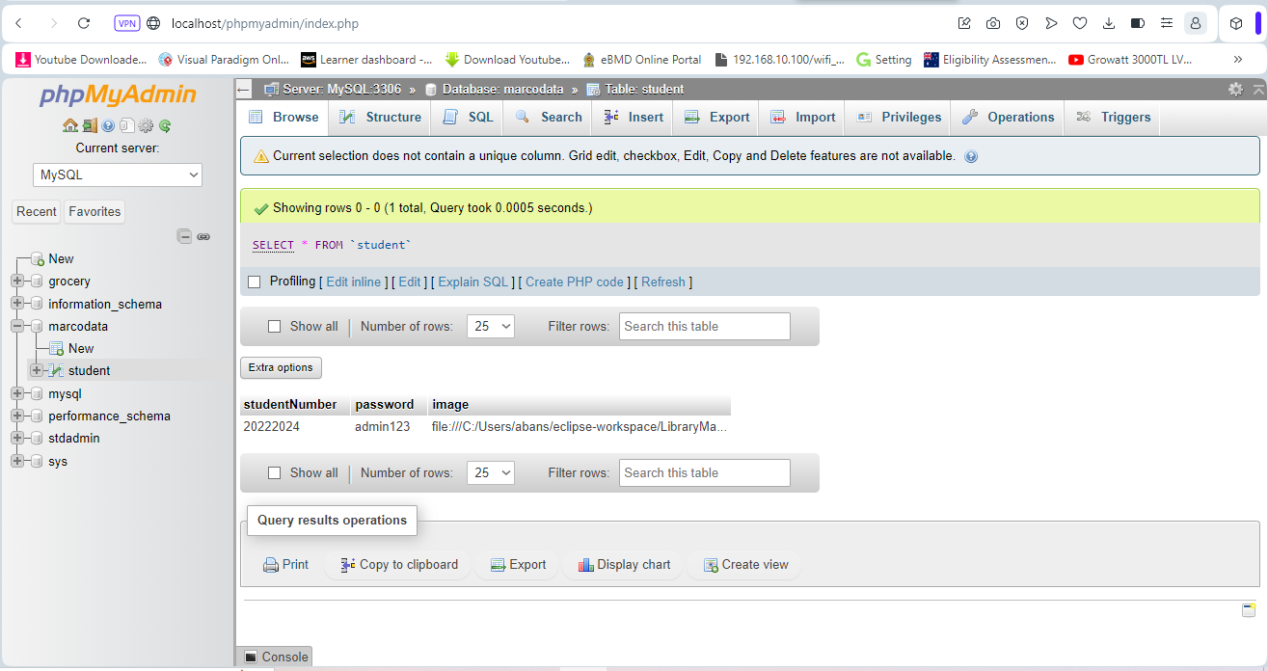

Eclipse Dev env

Scene Builder (Java FX)

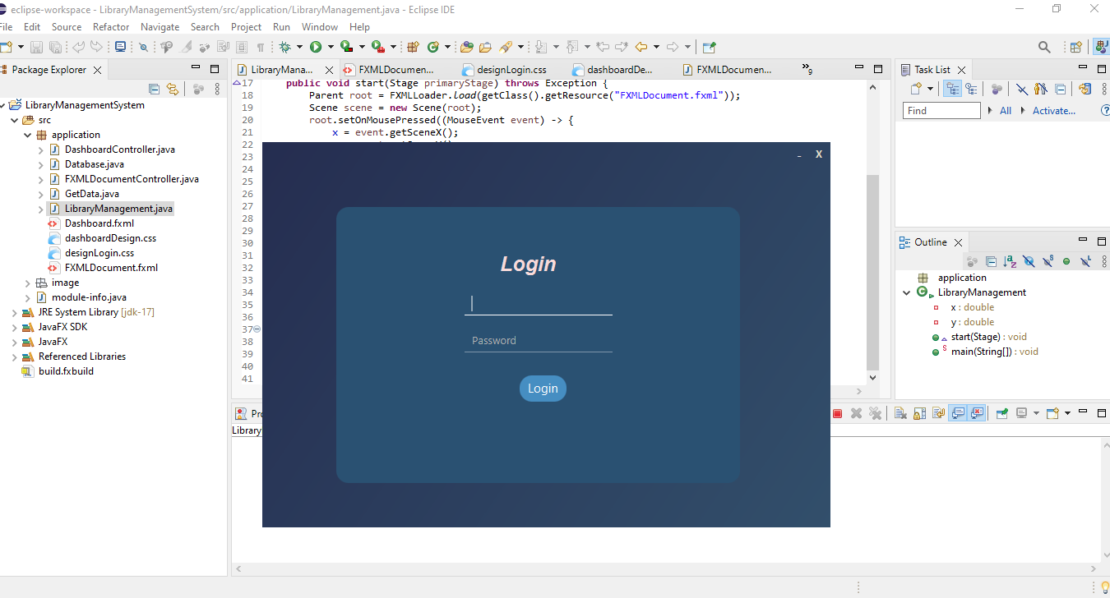

Run Application and Text user validation with DB

UIs:

